
Assignment – Static Portfolio Webpage
Submitted by-Priyanshu Kathuria
Roll No.-2501360014
Programme and Batch- B.Tech CSE(UX-UI),1st year
Subject-Computer Science Fundamentals & Career Pathway
Subject Code-ETCCCP105
Submitted to – MR. Rajesh
- Project Overview
The mini-project developed is a Static Portfolio Webpage. This project was selected from the assignment options and demonstrates foundational web development skills using HTML for structure and CSS for styling.

Project Features:
- Responsive Header & Navigation: A sticky header with navigation links (_{#hero}, #projects, _{#skills}, _{#contact}) allowing users to quickly jump between sections.
- Hero Section: Includes a photo, name (Priyanshu Kathuria), and a brief professional introduction.
- Projects Section: Displays four distinct project concepts, each with a detailed description (e.g., E-Commerce Store, MacOS Simulator).
- Skills Table: Presents core skills (HTML, CSS, JavaScript, Python) and their corresponding proficiency levels in an organized table format.
- Contact Form: A basic HTML form structured within a table for collecting visitor information (Name, Email, Phone, Message).
- Design & Aesthetics: Uses the Poppins and Noto Sans font families and features clear interactive elements via CSS hover effects.
- Back to Top Button: A fixed-position button is available for easy page navigation.
- Development Tools and process
The project was executed by utilizing the required modern development tools and following professional version control practices.

Visual Studio Code
- VS Code was used for writing and testing the code. This facilitated efficient development through its integrated terminal, syntax highlighting for HTML and CSS, and code testing capabilities.

Git and Github Usage

The project utilized Git for version control and is hosted on GitHub.

Git Command use | Purpose
Git add | Staged file changes (index.html and style.css).
Git commit -m “ | Committed staged changes with descriptive messages.
Git push | Pushed committed changes to the GitHub repository.
Git init | Initialised the local repository

Commit History
The project required a minimum of five meaningful commits. The following commits were executed with descriptive messages:
- Initial commit: Setup HTML structure and basic CSS and other files/folders
- Feature: Added Hero Section and navigation links
- Feature: Implemented Projects and Skills Sections
- Style: Refined CSS for professional aesthetics and hover effects
- Feature: Added Contact Form and Footer Elements
- Docs: Added README.md and .gitignore files
3.Repository Structure and Documentation

- index.html and style.css: The core source code.
- _{.gitignore}: Included to exclude unnecessary files like _{.vscode/} configuration folders.
- _{README.md}: Contains the project title, description, installation instructions, and feature list.
- _{docs/} folder: Contains markdown-based documentation files.
Screenshot in Readme.md
A screenshot of the application must be included in the _{README.md} file.

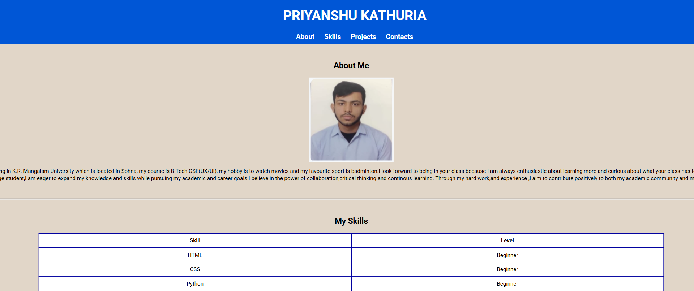
Markdown based documentation (in docs/folder)
- Project Overview (_{docs/overview.md}): Provides the goal (showcasing skills and projects), target audience (recruiters, collaborators), and a summary of the site's structure.
- Development Process (_{docs/development.md}): Details the use of semantic HTML, the application of modular CSS for styling, and the Git workflow used throughout the project build.
- Future Improvements (docs/future_improvements.md): Outlines planned enhancements.
4.Relevant to Real world context/use
This project directly addresses real-world demands by:
Professional Demonstration: It serves as a necessary professional tool for demonstrating front-end development capabilities to potential employers.
Industry Tools: The development process mandated the use of VS Code, Git, and GitHub, which are the fundamental tools used in almost all professional software development environments.
Documentation Skill: Creating a comprehensive _{README.md} and supporting documentation is a non-coding skill critical for project maintainability and collaboration in a team setting.
5.Future Improvements
Future plans for this project focus on enhancing functionality and design complexity:
- Responsiveness: Implement CSS Media Queries, Flexbox, or Grid to ensure the layout adapts perfectly to all screen sizes (mobile, tablet, desktop).
- JavaScript Integration: Add client-side validation to the Contact Form and introduce interactive UI features like a Dark Mode toggle.
- Bonus Collaboration: If time allows, complete the bonus task by collaborating with a peer using Git branching and Pull Requests on GitHub.
Repository Link
The fully functional mini project with source code and documentation is hosted on GitHub:
Github Link

